**Project Report**

**Employee Absenteeism**

Sourav

19 December, 2018

Contents

**1. Introduction**

1.1 Problem Statement . . . . . . . . . . . . . . . . . . . . . . . . . . . . . . . . . . . . . . . . . . 3

1.2 Data . . . . . . . . . . . . . . . . . . . . . . . . . . . . . . . . . . . . . . . . . . . . . . . . . . . . . . 3

1.3 Exploratory Data Analysis . . . . . . . . . . . . . . . . . . . . . . . . . . . . . . . . . . . . . 5

**2. Methodology**

2.1 Pre Processing . . . . . . . . . . . . . . . . . . . . . . . . . . . . . . . . . . . . . . . . . . . . . .

2.1.1 Missing Value Analysis . . . . . . . . . . . . . . . . . . . . . . . . . . . . . . . . . . . . . .

2.1.2 Outlier Analysis . . . . . . . . . . . . . . . . . . . . . . . . . . . . . . . . . . . . . . . . . . .

2.1.3 Feature Selection . . . . . . . . . . . . . . . . . . . . . . . . . . . . . . . . . . . . . . . . . .

2.1.4 Feature Scaling . . . . . . . . . . . . . . . . . . . . . . . . . . . . . . . . . . . . . . . . . . .

2.1. Sampling . . . . . . . . . . . . . . . . . . . . . . . . . . . . . . . . . . . . . . . . . . . . . . . .

2.2 Modeling . . . . . . . . . . . . . . . . . . . . . . . . . . . . . . . . . . . . . . . . . . . . . . . . . .

2.2.1 Linear Regression . . . . . . . . . . . . . . . . . . . . . . . . . . . . . . . . . . . . . . . . .

2.2.2 Random Forest . . . . . . . . . . . . . . . . . . . . . . . . . . . . . . . . . . . . . . . . . . . .

**3. Modelling**

3.1 Decision tree . . . . . . . . . . . . . . . . . . . . . . . . . . . . . . . . . . . . . . . . . . .

3.2 Random forest . . . . . . . . . . . . . . . . . . . . . . . . . . . . . . . . . . . . . . . . . . . .

3.3 Linear regression . . . . . . . . . . . . . . . . . . . . . . . . . . . . . . . . . . . . . . . . . . . . . . . .

**4. Conclusion**

4.1 Model evaluation

**5. Visualizations**

**Chapter 1**

**Introduction**

* 1. **Problem Statement**

XYZ is a courier company. As we appreciate that human capital plays an important role in collection, transportation and delivery. The company is passing through genuine issue of Absenteeism. The company has shared it dataset and requested to have an answer on the following areas:

1. What changes company should bring to reduce the number of absenteeism?

2. How much losses every month can we project in 2011 if same trend of absenteeism continues?

* 1. **Data**

There are 21 variables in our data in which 20 are independent variables and 1 (Absenteeism time in hours) is dependent variable. Since our target variable is a continuous variable, this is a regression problem.

**Variables Information:**

**1.** Individual identification (ID)

**2.** Reason for absence (ICD) -

Absences attested by the **International Code of Diseases** (ICD) stratified into 21 categories (I to XXI) as follows:

**I**. Certain infectious and parasitic diseases

**II**. Neoplasms

**III.** Diseases of the blood and blood-forming organs and certain disorders involving the immune mechanism

**IV**. Endocrine, nutritional and metabolic diseases

**V**. Mental and behavioral disorders

**VI**. Diseases of the nervous system

**VII**. Diseases of the eye and adnexa

**VIII**. Diseases of the ear and mastoid process

**IX**. Diseases of the circulatory system

**X**. Diseases of the respiratory system

**XI**. Diseases of the digestive system

**XII**. Diseases of the skin and subcutaneous tissue

**XIII**. Diseases of the musculoskeletal system and connective tissue

**XIV**. Diseases of the genitourinary system

**XV**. Pregnancy, childbirth and the puerperium

**XVI**. Certain conditions originating in the perinatal period

**XVII**. Congenital malformations, deformations and chromosomal abnormalities

**XVIII**. Symptoms, signs and abnormal clinical and laboratory findings, not elsewhere classified

**XIX**. Injury, poisoning and certain other consequences of external causes

**XX.** External causes of morbidity and mortality

**XXI**. Factors influencing health status and contact with health services

And 7 categories without (CID) patient follow-up (22), medical consultation (23), blood donation (24), laboratory examination (25), unjustified absence (26), physiotherapy (27), dental consultation (28).

**3.** Month of absence

**4.** Day of the week (Monday (2), Tuesday (3), Wednesday (4), Thursday (5), Friday (6))

**5.** Seasons (summer (1), autumn (2), winter (3), spring (4))

**6.** Transportation expense

**7.** Distance from Residence to Work (kilometers)

**8.** Service time

**9.** Age

**10.** Work load Average/day

**11.** Hit target

**12.** Disciplinary failure (yes=1; no=0)

**13.** Education (high school (1), graduate (2), postgraduate (3), master and doctor (4))

**14.** Son (number of children)

**15.** Social drinker (yes=1; no=0)

**16.** Social smoker (yes=1; no=0)

**17.** Pet (number of pet)

**18.** Weight

**19.** Height

**20.** Body mass index

**21**. Absenteeism time in hours (target)

* + 1. **Data set:**

Data is described upon parameters such as the Reason for Absence, various things involved, health issue or work load would be the reason. The table represents a sample of various fields available in the data.

**Table 1.1** Absenteeism at Work (Column 1-7)

|  |  |  |  |  |  |  |  |  |  |  |  |
| --- | --- | --- | --- | --- | --- | --- | --- | --- | --- | --- | --- |
| ID | Reason for absence | Month of absence | Day of the week | Seasons | Transportation expense | Distance from Residence to Work | Service time | Age | Work load Average/day | Hit target | Disciplinary failure |
| 11 | 26 | 7 | 3 | 1 | 289 | 36 | 13 | 33 | 239,554 | 97 | 0 |
| 36 | 0 | 7 | 3 | 1 | 118 | 13 | 18 | 50 | 239,554 | 97 | 1 |
| 3 | 23 | 7 | 4 | 1 | 179 | 51 | 18 | 38 | 239,554 | 97 | 0 |
| 7 | 7 | 7 | 5 | 1 | 279 | 5 | 14 | 39 | 239,554 | 97 | 0 |
| 11 | 23 | 7 | 5 | 1 | 289 | 36 | 13 | 33 | 239,554 | 97 | 0 |

**Table 1.2** Absenteeism at Work (Column 8-14)

|  |  |  |  |  |  |  |  |  |
| --- | --- | --- | --- | --- | --- | --- | --- | --- |
| Education | Son | Social drinker | Social smoker | Pet | Weight | Height | Body mass index | Absenteeism time in hours |
| 1 | 2 | 1 | 0 | 1 | 90 | 172 | 30 | 4 |
| 1 | 1 | 1 | 0 | 0 | 98 | 178 | 31 | 0 |
| 1 | 0 | 1 | 0 | 0 | 89 | 170 | 31 | 2 |
| 1 | 2 | 1 | 1 | 0 | 68 | 168 | 24 | 4 |

As we can see in the table below we have the following 21 variables, using which we have to correctly predict the Employee Absenteeism time in hour for our target variable.

Summary of data is given below to know variables types and dimension of data.

**Fig 1.1** Summary of data

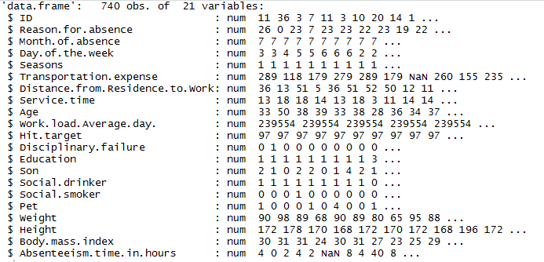

**1.3 Exploratory Data Analysis**

Exploratory Data Analysis (EDA) is an approach to analyzing data sets to summarize their main characteristics. In the given data set there are 21 variables and data types of all variables are either float64 or int64. There are 740 observations and 21 columns in our data set. Missing value is also present in our data.

**List of variables and their types:**

ID int64

Reason for absence object

Month of absence object

Day of the week object

Seasons object

Transportation expense float64

Distance from Residence to Work float64

Service time object

Age float64

Work load Average/day float64

Hit target object

Disciplinary failure object

Education object

Son object

Social drinker object

Social smoker object

Pet object

Weight float64

Height float64

Body mass index float64

Absenteeism time in hours float64

dtype: object

**From EDA we have concluded that there are 10 continuous variable and 11 categorical variable in nature.**

# **Methodology**

## **2.1 Data Preprocessing**

Data in real world is dirty it of no use until unless we apply data preprocessing on it. In other words, Pre- processing refers to the transformations applied to your data before feeding it to the algorithm. It’s a data mining technique which that involves transforming raw data into an understandable format or we can say that it prepares raw data to further processing. There are so many things that we do in data preprocessing like data cleaning, data integration, data transformation, or data reduction.

### **2.1.1 Missing Value Analysis**

Missing Values Analysis is use to fill NULL values in data with some imputation techniques

But here in our Employee Absenteeism Data, we have null Values. By the way our data contain missing value. We will impute those values using KNN.

**Fig 2.1** Number of missing Values

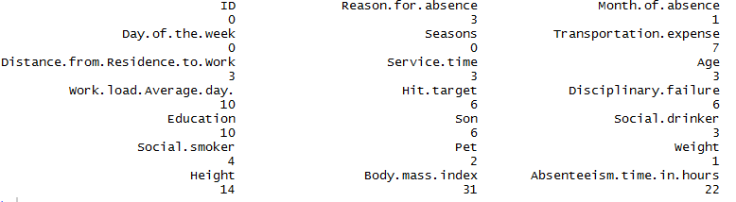

### 

### **2.1.2 Outlier Analysis**

The shown boxplot Fig: 2.3 refers outliers on the predictors variables, we can see various outliers associated with the features. Even though, the data has considerable amount of outliers, the approach is to retain every outlier and grab respective behavior of all employees. As shown there are significant

amount of outliers present in the target variable, which indicates a trend on Employee ' behavior, there can be pattern , we need to treat those outliers.

**Fig 2.3** Outlier Values

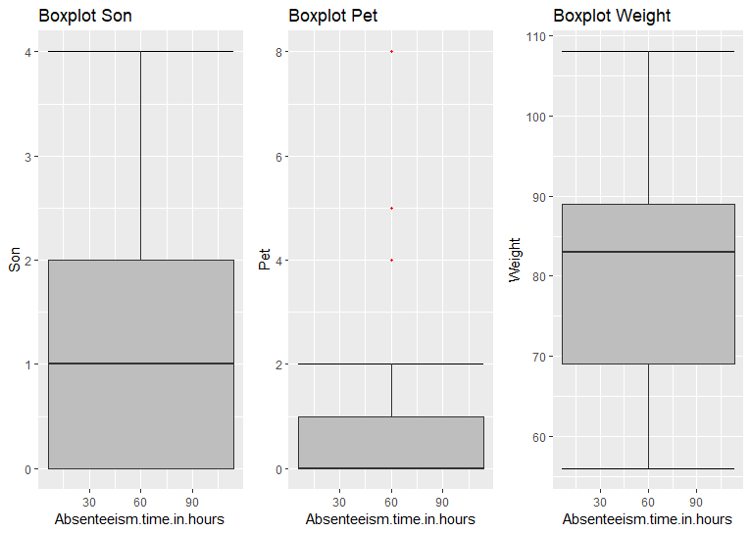

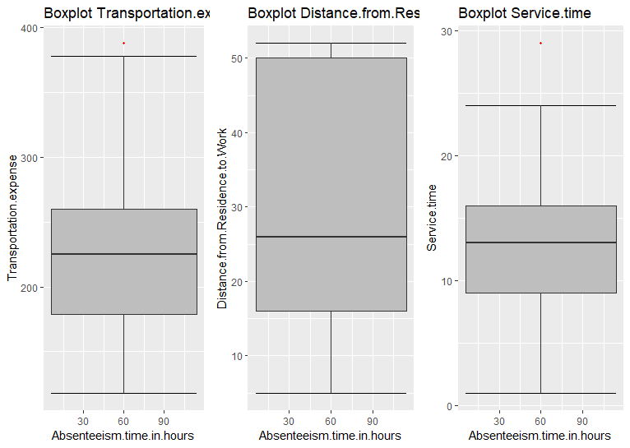

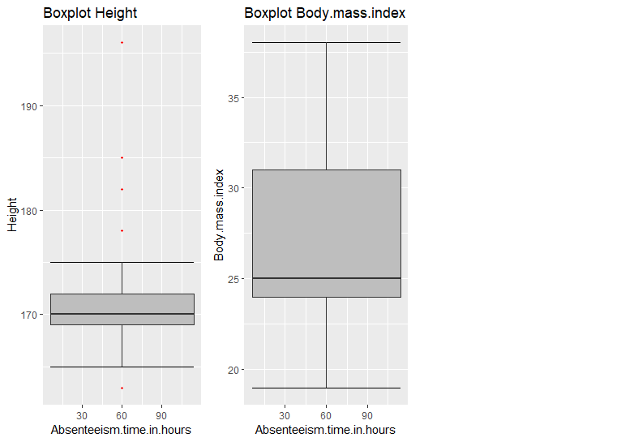

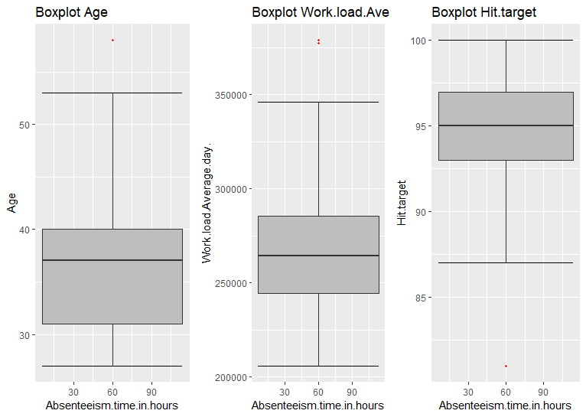

From the boxplot almost all the variables **except “Distance from residence to work”, “Weight” and “Body mass index”** consists of outliers. We have converted the outliers (data beyond minimum and maximum values) as NA i.e. missing values and fill them by **KNN** imputation method.

In figure we have plotted the boxplots of the 11 predictor variables with respect to **Absenteeism time in hour**. A lot of useful inferences can be made from these plots. First as you can see, we have a lot of outliers and extreme values in each of the data set.

## **2.1.3 Feature Engineering**

Feature Engineering is described as the knowledge extraction process, where important features are selected using domain knowledge to make a machine learning algorithm work. There can be features that aren't relevant for the analysis, we can remove such variables using numerous ways. However, we

Considered taking correlation on the variables and make a heat map Fig: 2.5 to check relationships among the features and then dropping redundant variables.

**Fig 2.5** Correlation plot of variables

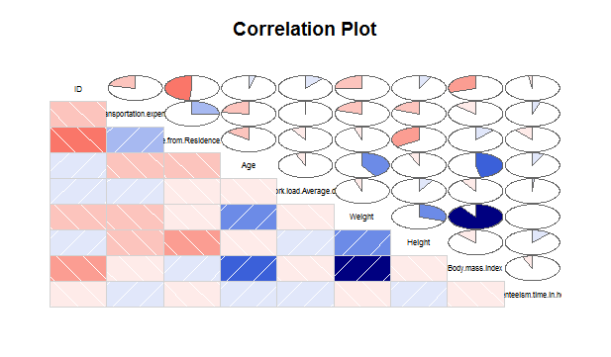

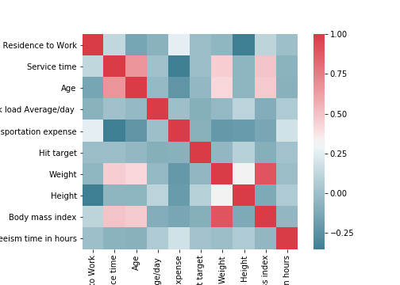

From these graph we can see that there are some variables which have collinearity problems or they are highly correlated.

1. The weight predictor is highly correlated to body mass index
2. On applying the chi square test, the p values of the following variables are found to be greater than 0.05, ID, Education, Social.smoker, Pet.

One of the assumptions of logistic regression is that logistic regression requires there to be little or no multicollinearity among the independent variables. This means that the independent variables should not be too highly correlated with each other. Due to this assumption, one the predictors from each set was removed when logistic learner was trained.

**2.1.4 Feature Scaling**

Checking distribution curve for all continuous variable

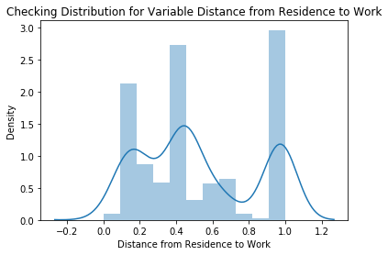 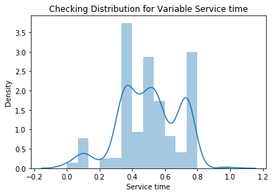

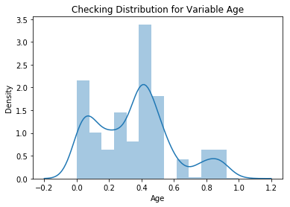 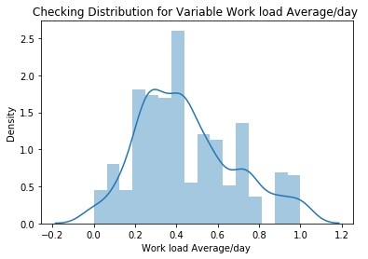

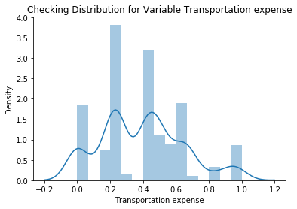 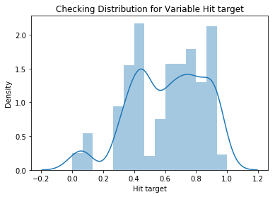

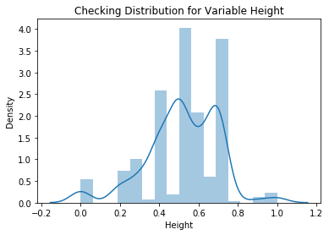 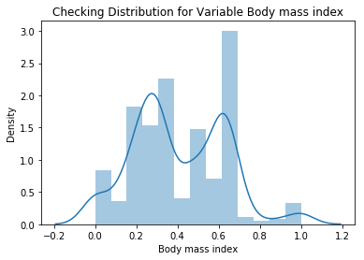

**Feature scaling** is a method used to standardize the range of independent variables or features of data. In data processing, it is also known as data normalization and is generally performed during the data preprocessing step. Since the range of values of raw data varies widely, in some machine learning algorithms, objective functions will not work properly without normalization. For example, the majority of classifiers calculate the distance between two points by the Euclidean distance. If one of the features has a broad range of values, the distance will be governed by this particular feature. Therefore, the range of all features should be normalized so that each feature contributes approximately proportionately to the final distance. Since our data is not uniformly distributed we will use **Normalization** as Feature Scaling Method.

**2.1.5 Sampling**

The dataset is been divided into 2 parts train data to train a machine learning model and test data to test the model accuracy

The data is divided into 8:2 ratio that means 80% of data is training data and rest 20% data is test data.

# **Modelling**

Absenteeism at work is a regression problem. Here according to the problem statement, we are supposed to predict the loss incurred by the company if the same pattern of absenteeism continues. Hence we are selection the following two models,

1. Decision tree
2. Random forest model

Both training models Decision tree and random forest were implemented in R and python. After building an initial model, performance tuning was done using hyper parameter tuning for optimized parameters.

## **3.1 Decision Tree**

Train data was divided into train dataset and validation set.

• Logistic regression models were trained on train dataset.

• Validation set and AIC score was used to select the best models out of all trained models.

• Final test and prediction was performed on test data which was provided separately.

**R implementation:**

##model development (decision tree regression model)

*#reg_model = rpart(Absenteeism.time.in.hours ~. , data = train, method = "anova")*

*#predicting reg_model for test cases*

*#predictions = predict(reg_model , test[,-14])*

#RMSE OR MSEis the technique which can be used to evaluate the performance of a regression model

#here, i will use root mean square error technique to evaluate the performance of the model, moreover the data is a time series data

*#library("DMwR")*

*#RMSE = regr.eval(test[,14], predictions, stats = 'rmse')*

*#RMSE #14.92*

##accuracy = 85.02%

## Thus in Decision tree regression model the error is 14.92 which tells that our model is 85.08% accurate____

**Python implementation:**

*from sklearn.tree import DecisionTreeRegressor*

*#Decision tree for regression*

*fit_DT = DecisionTreeRegressor(max_depth=2).fit(train.iloc[:,0:9], train.iloc[:,9])*

*#checking for any missing valuses that has leeked in*

*np.where(data.values >= np.finfo(np.float64).max)*

*test = test.fillna(train.mean())*

*#Decision tree for regression*

*fit_DT = DecisionTreeRegressor(max_depth=2).fit(train.iloc[:,0:15], train.iloc[:,15])*

*#Apply model on test data*

*predictions_DT = fit_DT.predict(test.iloc[:,0:15])*

*def rmse(predictions, targets):*

*return np.sqrt(((predictions - targets) ** 2).mean())*

*rmse(test.iloc[:,15], predictions_DT)*

*#rmse using DT = 0.16972039562573937*

## 

## **3.2 Random Forest**

After decision tree, random forest was trained. It was implemented in both R and python. In both implementations random forest was first trained with default setting and the hyper parameters tuning was used to find the best parameters.

**R Implementation:**

*library("randomForest")*

*RF_model = randomForest(Absenteeism.time.in.hours~. , train, importance = TRUE, ntree=100)*

#Extract the rules generated as a result of random Forest model

*library("inTrees")*

*rules_list = RF2List(RF_model)*

#Extract rules from rules_list

*rules = extractRules(rules_list, train[,-14])*

*rules[1:2,]*

#Convert the rules in readable format

*read_rules = presentRules(rules,colnames(train))*

*read_rules[1:2,]*

#Determining the rule metric

*rule_metric = getRuleMetric(rules, train[,-14], train$Absenteeism.time.in.hours)*

*rule_metric[1:2,]*

#Prediction of the target variable data using the random Forest model

*RF_prediction = predict(RF_model,test[,-14])*

*RMSE_RF = regr.eval(test[,13], RF_prediction, stats = 'rmse')*

*#RMSE = 7.88*

**#Accuracy = 92.12%**

#Thus the error rate in Random Forest Model is 7.88% and the accuracy of the model is 100-7.88 = 92.12%.

**Python implementation:**

#Divide data into train and test

*X = data.values[:, 0:15]*

*Y = data.values[:,15]*

*X_train, X_test, y_train, y_test = train_test_split( X, Y, test_size = 0.2)*

*from sklearn.ensemble import RandomForestRegressor*

*# Building model on top of training dataset*

*fit_RF = RandomForestRegressor(n_estimators = 500).fit(X_train,y_train)*

*# Calculating RMSE for test data to check accuracy*

*RF_predictions_test = fit_RF.predict(X_test)*

*rmse_for_test =np.sqrt(mean_squared_error(y_test,RF_predictions_test))*

**rmse_for_test = 0.18017389276028373**

## **3.3 Linear regression:**

###________________ LINEAR REGRESSION _______________________________

*#library("usdm")*

*#LR_data_select = subset(data_sorted ,select = -c(Reason.for.absence,Day.of.the.week))*

*#colnames(LR_data_select)*

*#vif(LR_data_select[,-12])*

*#vifcor(LR_data_select[,-12], th=0.9)*

*####Execute the linear regression model over the data*

*#lr_model = lm(Absenteeism.time.in.hours~. , data = train)*

*#summary(lr_model)*

*#colnames(test)*

**###___Multiple R-squared: 0.2674, Adjusted R-squared: 0.1953, which means our target variable can explain 26.74% of variance which is not acceptable**.

#Predict the data

*#LR_predict_data = predict(lr_model, test[,1:13])*

#Calculate MAPE

*#MAPE(test[,14], LR_predict_data)*

*#library(Matrix)*

*#rmse(test[,14],LR_predict_data)*

##linear regression model works best for continuous variables, but here in LR_data_select we have categorical variables.

**##________ Till here we have implemented Decision Tree, Random Forest and Linear Regression. Among all of these Random Forest is having highest accuracy**.

**Python implementation:**

# Importing libraries for Linear Regression

*from sklearn.linear_model import LinearRegression*

# Building model on top of training dataset

*fit_LR = LinearRegression().fit(X_train , y_train)*

# Calculating RMSE for training data to check for over fitting

*LR_pred_train = fit_LR.predict(X_train)*

*rmse_for_train = np.sqrt(mean_squared_error(y_train,LR_pred_train))*

# Calculating RMSE for test data to check accuracy

*LR_pred_test = fit_LR.predict(X_test)*

*rmse_for_test =np.sqrt(mean_squared_error(y_test,LR_pred_test))*

*print("Root Mean Squared Error For Training data = "+str(rmse_for_train))*

*print("Root Mean Squared Error For Test data = "+str(rmse_for_test))*

Root Mean Squared Error For Training data = 0.17189637356023962

Root Mean Squared Error For Test data = 0.20422938819536107

# **Conclusion**

## 4.1 Model Evaluation

As we can see, we have applied all the possible preprocessing analysis to our dataset to make it suitable

For calculation.

We have also removed the missing values and outliers.

Now since our data is a regression model, we have applied suitable models

Such as decision tree and random forest.

The error metric results of both the models are as follows,

**Using R,**

**Rmse** value applying decision tree, **0.1492**

This means that our predictions vary from the actual value by about 0.1492

**Rmse** value using random forest, **0.0788**

This means that our predictions vary from the actual value by about 0.0.0788

**Rmse** value using linear regression, **0.2694**

This means that our predictions vary from the actual value by about 0.2694

**Using python,**

**Rmse** value applying decision tree, **0.16972**

This means that our predictions vary from the actual value by about 0.16972

**Rmse** value using random forest**, 0.18017**

This means that our predictions vary from the actual value by about 0.18017

**Rmse** value using linear regression, **0.20422**

This means that our predictions vary from the actual value by about 0.20422

Hence comparing R and python, since the error rate of R is comparatively better, we consider the code of R

AND on comparing the values of decision tree and random forest, since the error rate of random forest is comparatively better, we consider the value of random forest.

**Hence, finally, we are accepting the random forest model of R, which has an RMSE value of 0.18017, which is negligible.**

1. **Visualizations:**

**ANALYSING ABSENTEEISM TREND ON TEST DATA**

**Below are some suggestions and visualizations that a company should take forward to reduce its rate of absenteeism based on the data provided.**

**The Changes which company should bring to reduce the number of absenteeism –**

1. Employees who are social drinker have more absentee hour than who are not social drinker.

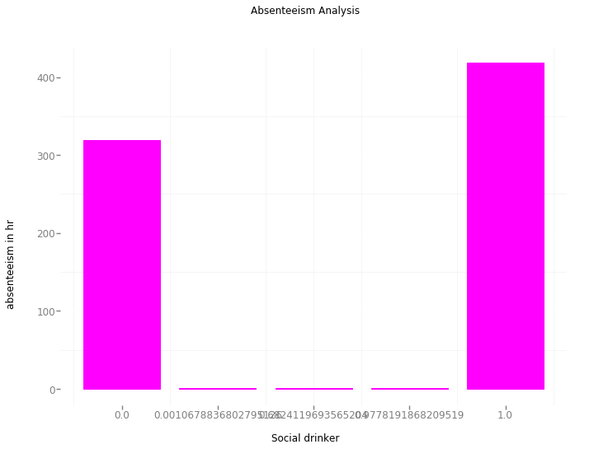

As a drinker is more prone to bad health condition so that causes a lot of absenteeism. So a firm should conduct health campaigns to educated employee about the harmful effects of smoking.

1. Most often Reason for absence are medical consultation and dental consultation, company should take care of it. The maximum people taking the absent hours are from category 23 followed by 28 and 27. These category are not attested by doctors. 23: Medical Consultation. 28: Dental consultation 27: Physiotherapy .

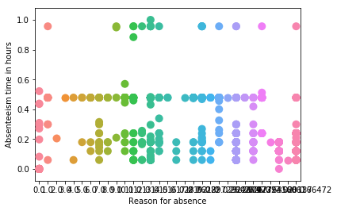

Other than the above statements

* A company should introduce 100% attendance incentive bonus.
* Should introduce new policy for salary deduction for un-informed or un-approved leaves
* A sandwich leave policy would be a good option to reduce absenteeism on day near to weekends.

1. Most of the employees are absent on Monday.

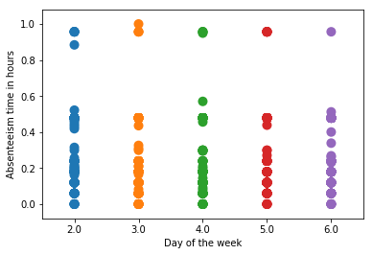

A company should motivate their employees for not being lazy.

1. Company should provide transportation expense to employees who are communicating from a considerable distance.

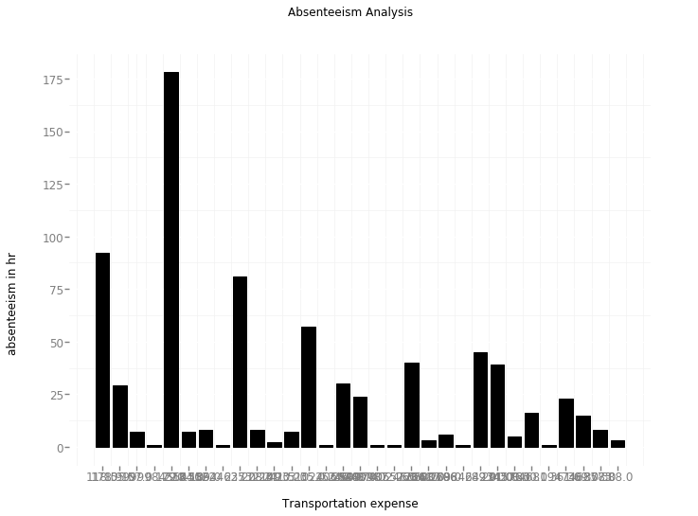

1. A company should provide cab facility to ease the transportation towards employees.

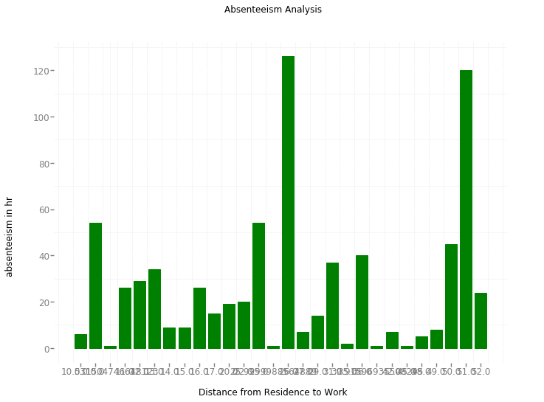

1. A company should provide proper teaching and training to their employees after interval of time as the discipline is the key to growth.

